ITC 220 Final Project

Mission statement

* The purpose of the Restaurant database is to maintain the data the staff uses to operate the restaurant and serve the patrons quickly and efficiently.

Mission objectives

* Maintain vendor contact information
* Maintain employee contact information
* Keep track of all customer sales
* Track where supplies are purchased from
* Track popularity of dishes

Database requirements

* Store vendor contact information
* Store employee contact information
* Display menu items sorted by type
* Store order data for each transaction
* Document dates of supply orders

Business rules

* All orders must have a employee and table
* All dishes must have a price
* Dishes are one of the following: drink, side, entree, appetizer, misc

Research: are there other DB’s online that match your own requirements? What do they look like? What can you learn from them?

* <https://www.researchgate.net/figure/Database-Schema-for-the-Restaurant-Ordering-System_fig4_323230406>
* This diagram seem to be trying to accomplish task that are more suited for the UI to handle. Also at a restaurant I do not think you will have the opportunity to get all information the Customer table is asking for, without being intrusive.
* <https://www.chegg.com/homework-help/questions-and-answers/assignment-develop-relational-schema-conceptual-data-model-relatively-simple-restaurant-da-q27224163>
* This diagram seems a little too detailed. We can be as granular as we want with the materials needed, but this may make using a database a chore constantly having to update this like the amount of each ingredient used in a dish. It also stores credit card information which I think should be left to security experts like the company Veriphone.

Stakeholders (this would be you and anyone else using the DB)

* Business owner
* Employees
* Customers

Preliminary field list

* Subjects
  + Customers
  + Employees
  + Dish
  + Sale
  + Supplies
  + Tables
  + Vendors
  + Order
* Characteristic
  + Dish ID
  + Dish Name
  + Dish Type
  + Dish Price
  + Employee ID
  + Employee First Name
  + Employee Last Name
  + Employee Title
  + Employee Phone Number
  + Order ID
  + Order Date
  + Oder Time
  + Table
  + Tax Percentage
* Calculated
  + GrandTotal
  + Item Total

Preliminary entity list

* Customers
* Employees
* Dishes
* Supplies
* Tables
* Vendors
* Order

Identify primary keys

* Customer ID
* Employee ID
* Dish ID
* Supplies ID
* Tables ID
* Vendors ID
* Order ID

Run your ERD through 1NF, 2NF, and 3NF. Explain why your ERD is or isn’t in 1st, 2nd, or 3rd Normal Form and correct your ERD as needed.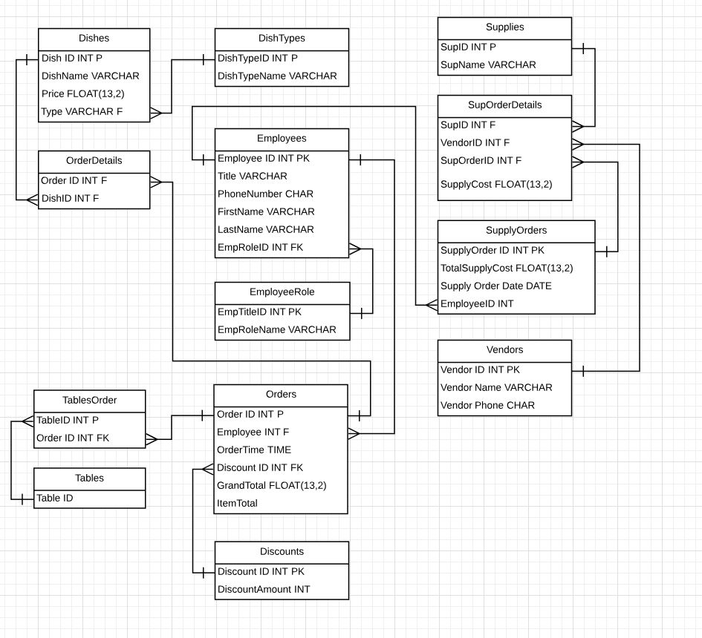

* 1NF - There is no repeating groups and all tables have a primary key
* 2NF - There are no partial dependencies of any of the columns on the primary key
* 3NF - All non-primary fields are dependent on the primary key.

Define data views (your DB should have at least one view)

* Menu Items with price organized by Dish Type

Review data integrity (steps are in the appendix of your book)

Final ERD

Security diagram

* <https://docs.google.com/spreadsheets/d/14bjpQ0DApocj12Rx626OkQxQg2A54iHs7WdOMi3eaGg/edit?usp=sharing>

Implementation:

Use MSSQL server or MySQL to implement your database design

Enter at least five rows of data in each table for testing purposes

Create at least one view

Create users or roles for security (Make sure to have at least one DBA)

Execute (and screenshot) three queries that answer questions you have about how your DB is working. At least one of these should be a join.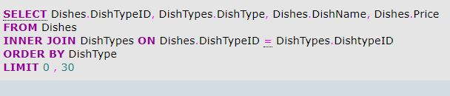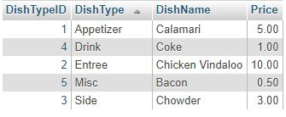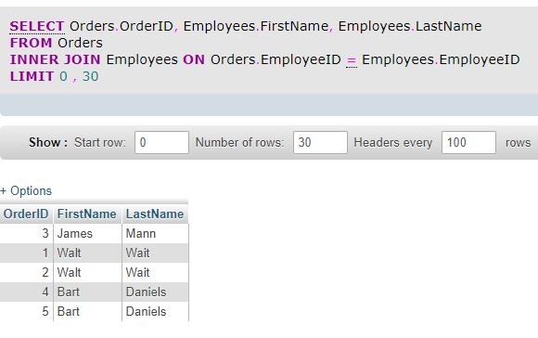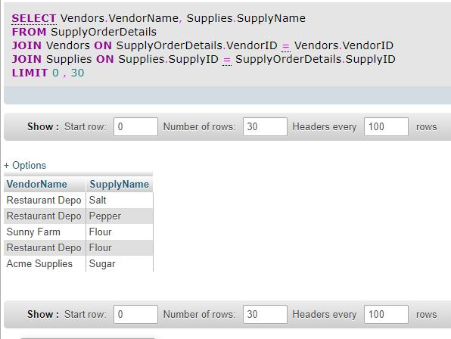

Test your DB users/roles by logging in as each user/role and performing tasks

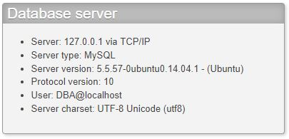

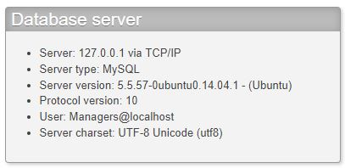

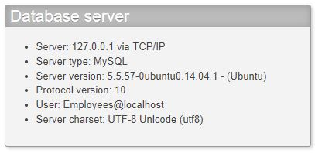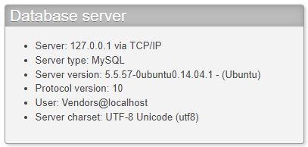

Test your Business rules

* All orders must have a employee and table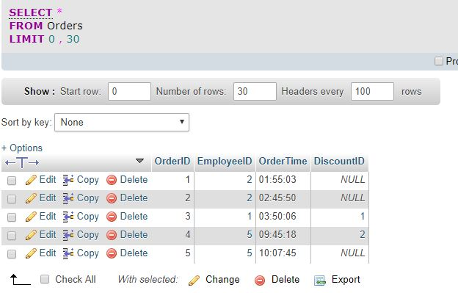
* All dishes must have a price
* 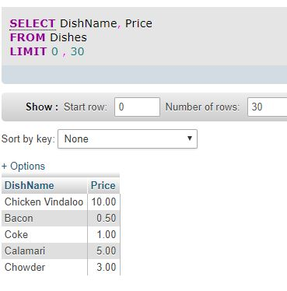
* Dishes are one of the following: drink, side, entree, appetizer, misc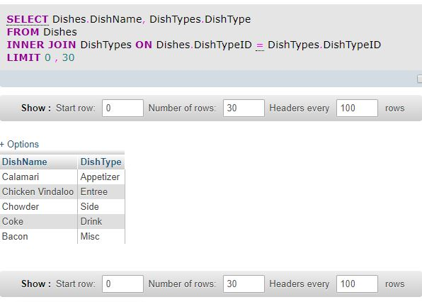

Test your mission objectives

* Maintain vendor contact information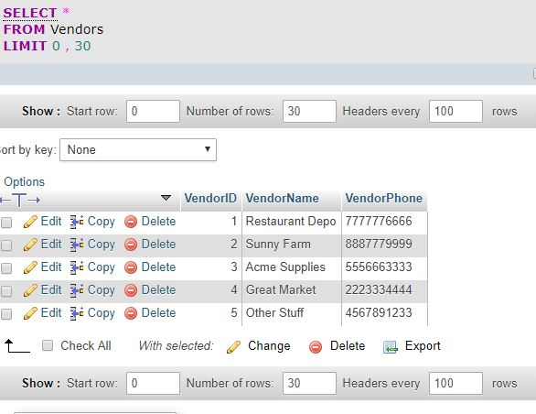
* Maintain employee contact information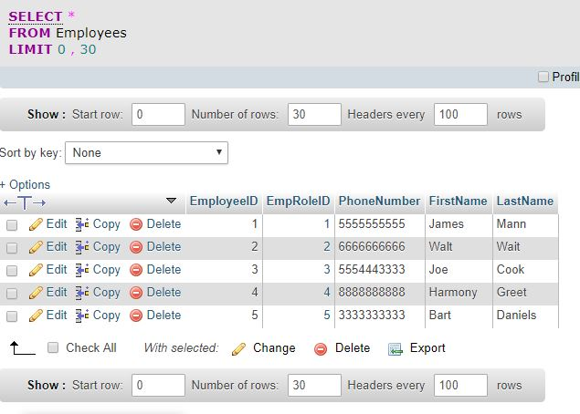
* Keep track of all customer sales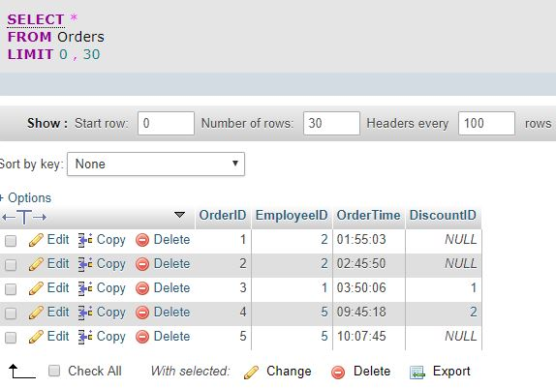
* Track where supplies are purchased from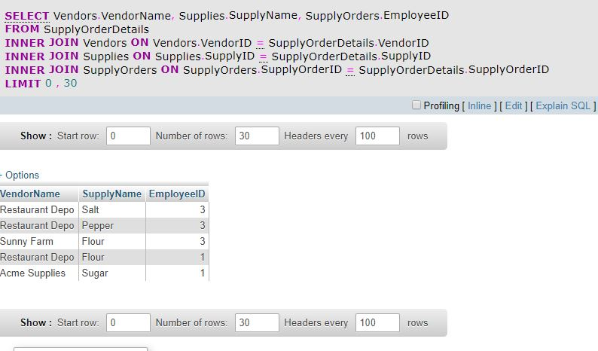
* Track popularity of dishes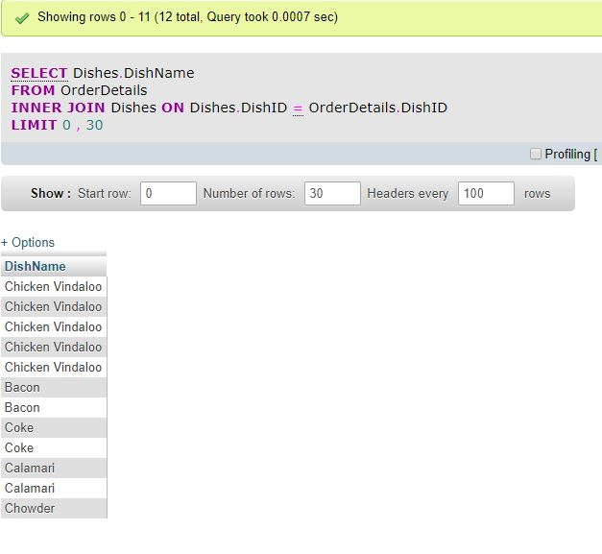

Test your database requirements

* Store employee contact information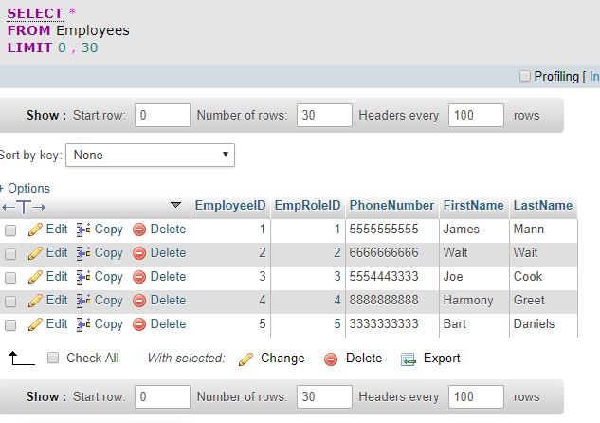
* Display menu items sorted by type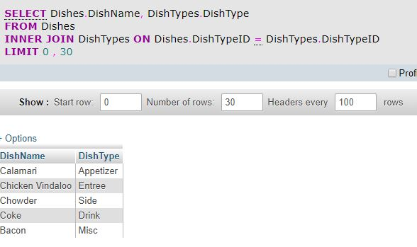
* Store order data for each transaction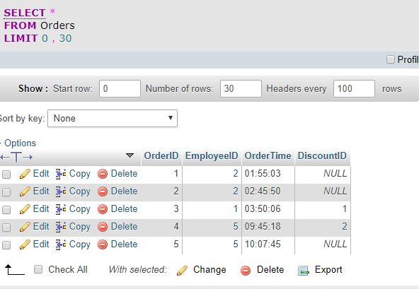
* Document dates of supply orders